Chapter 2, Solution 56

We need to find R_{eq} and apply voltage division. We first tranform the Y network to .
+
100 V
-
R_{eq}
15 Ω
12 Ω
10 Ω
30 Ω
16 Ω
35 Ω
20 Ω
+
100 V
-
R_{eq}
45 Ω
30 Ω
37.5 Ω
30 Ω
16 Ω
35 Ω
20 Ω
a
b
c

R_{ab} = 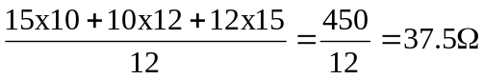
R_{ac} = 450/(10) = 45Ω, R_{bc} = 450/(15) = 30Ω

Combining the resistors in parallel,

30||20 = (600/50) = 12 Ω,

37.5||30 = (37.5x30/67.5) = 16.667 Ω

35||45 = (35x45/80) = 19.688 Ω

R_{eq} = 19.688||(12 + 16.667) = 11.672Ω

By voltage division,

v = 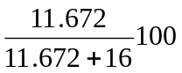 = 42.18 V

